Cyber and IS Threat Intelligence (+covers AU-121-04-CSDR Cyber & IS)
L2 test name: Cyber and IS Threat Intelligence
Legal entities in scope: DBAG, ExR, EFAG, ECAG, CBF, CH, CBL, LuxCSD, CI, CS, CFCL and ECC/EEX

Test(s) according to RCA:
(TP1) FuN 240722110510
In the next audit for topic Threat Intelligence, please review how information about Threat Intelligence (also e.g., including information about physical security or travel management) is collected and how it is combined / processed for reporting. Please specifically focus on a review of:
- Sources used for Threat Intelligence data and information and how these sources are processed and combined for the reporting.
- Completeness of the distribution list(s) regarding the relevant recipients including legal entity level to ensure necessary awareness about Threat Intelligence within DBG.
[Hint: A key document for reporting and its distribution to be considered is the monthly Cyber & Geopolitical Threat Intelligence Report by Group Security's – Cyber Defense. Also, refer TP5 of L2 Cyber and IS Detection].

(TP2) FuN 240913151535
During the 2024-056 Physical Security Audit, the Process Handbook for Intelligence Service has been checked. It was noted that even though the process has been transferred to Cyber Defense in March 2023, the document owner as of the latest update in December 2023 is still shown to be David Krüger from Physical Security. Furthermore, the descriptions in the Handbook don’t clearly indicate that the process is not under Physical Security anymore since some chapters are still mentioning Physical Security being in charge conducting some tasks. However, both David Krüger (from Physical Security) and Jonas Luedke (from Threat Intelligence) confirmed that the process wholly lies with Threat Intelligence. IA therefore advised Jonas Luedke to update the Handbook accordingly.
To Do: IA to check that the Handbook has been updated (regarding owner and clear allocation of responsibilities).

(TP3) “L2 AU-109-12-Threat Intelligence” may be covered to a limited extent, pertaining to DE and OE checks on automation controls applied for various threat feeds from multiple sources regarding arrangements (protection and response) for improved resilience against threats.

Audit procedures/source:
- Information directly requested from auditee (via e-mail or call) or extracted from provided documentation during preparation phase.

Conclusion:

Not ok, exception identified

Internal audit (AW, MM) has performed the following Audit procedures:

-------------------------------------------------------
Summary of work done:
-------------------------------------------------------

AP | Work done | Result
TP1 | IA inspected the document ‘Threat Intelligence Service Manual_v1.7’ and noted that the following types of information are collected as part of the Intelligence Gathering.  Open-Source Intelligence (OSINT)  Social Media Intelligence (SOCMIINT)  Human Intelligence (HUMINT)  The following are the sources of information mentioned in the document ‘Threat Intelligence Service Description_v1’. We observed that Dataminr was not added in the APMS Inventory.  We corroborated this information via inquiry with Olga Wenge, Jonas Luedke and noted that these sources are monitored by the Threat Intelligence team.  We noted that the following persons should receive Threat Intelligence alerts as part of the ‘Threat Intelligence Service Description_v1’.  - GS_Leadership + GS CD, CP, RM  - IT Direct Reports Christoph Boehm: &IT_DirectReportsCB@deutsche-boerse.com  - IT Extended Ldrship Team: &IT_extendedLeadershipTeam@deutsche-boerse.com  - CISOs: CISO and CICTRO List - ICT Risk / CISO - Knowledge  - TISOs: Technical Information Security Officers  - Business Leads (Board Members from LE)  - Central Functions (Compliance, GDP, Risk, Legal, Coms, Audit, Finance, Purchasing, Facility): Department and Section Lead  We sampled 3 reporting emails from a population of 12 reports for the period April 2024 – March 2025 to compare the distribution list in the emails for the sampled months against the distribution list mentioned in the ‘Threat Intelligence Service Description_v1’. We noted no deviation in the distribution list  TP 1  Yezad –  Conclusion: Dataminr missing from DBG’s application inventory (APMS)  Threat Intelligence information sources, collection, processing, and distribution (including the audience list) were verified and no exception noted. | N.OK
  Threat Intelligence Source | APMS ID
  - CrowdStrike CTI | AID2131
  - SecAlliance /Threat Match – Platofrm and feed | N/A
  - FS-ISAC – DORA driven Information sharing committee (ToR and NDA) published on website | N/A
  - Dataminr – platform for physical security TI | Issue Identified
  - MISP / CISII-EU | AID737
  - RANE networks | N/A
  - International SOS | N/A
  - DAX40/OpenISAC | N/A
  - Interpol/Europol | N/A
  - OSAC | N/A
  - CISA, BSI | N/A
  - Intelligence Services (BfV/LfV, BND) | N/A
  - S-RM | N/A
  - OSINT | N/A
TP2 | IA performed an inquiry with Olga Wenge (Head of Cyber Defense), and Jonas Luedke (Physical Security Specialist for Threat Intelligence) for the Topic of Physical Security Threat Intelligence. As part of the discussion, we understood that all written rule documents were updated to reflect the current organizational setup.  IA inspected ‘Threat Intelligence Process Handbook_Chapter 12_Travel Risk Management_v1.4’ and noted that document owner was changed from David Kruger, Head of Physical Security to Olga Wenge, Head of Cyber Defense. We further examined the document and observed that clear demarcation was listed between the actions to be performed by the Cyber Defense Team and the Physical Security Team. (See Page 3, Section 12: Travel Risk Management of the ‘Threat Intelligence Process Handbook_Chapter 12_Travel Risk Management_v1.4’). | OK
TP3 | IA sampled a few Threat Intelligence sources to check how data is collected and disseminated in actionable items to the concerned stakeholders.  - CrowdStrike  DBG has its own platform on the CrowdStrike to gather Cyber related threat intelligence indicators. These ‘indicators of compromise’ or IoC are gathered by setting up rules against known threat scenarios. Once an alert gets generated for any of these rules, a CrowdStrike Analyst identifies False Positives and forwards actionable IoCs to the DBG TI team.  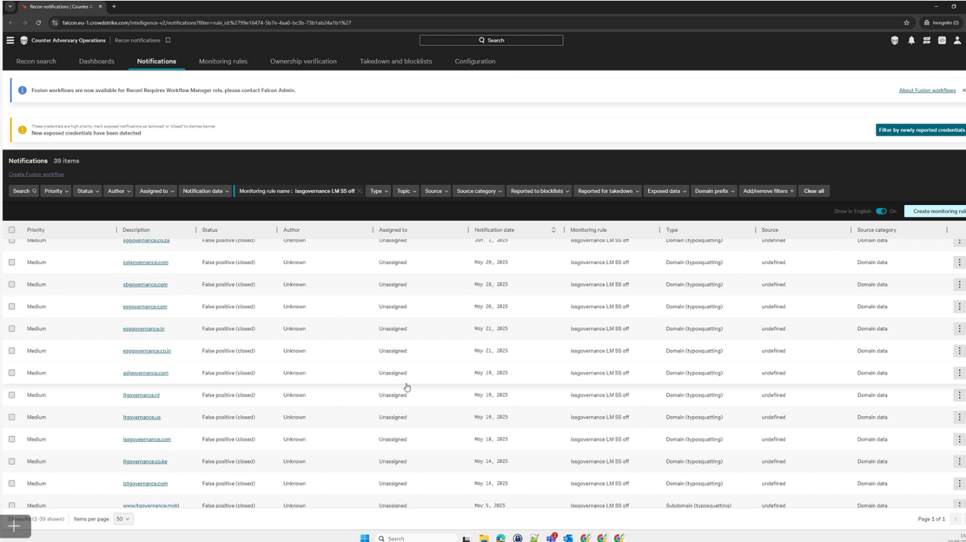  - Dataminr - Dataminr is an Artificial Intelligence and social media surveillance platform used by Cyber Defense to monitor real-time events, and to aid with crisis response by providing playbooks, messaging tools and post-event documentation. Jonas Luedke leads the data gathering process for Physical and Travel Security related threats. The team gets alerted via the platform for any perceived threat by the system. The team manually monitors these alerts and collects this information to be circulated to DBG employees.  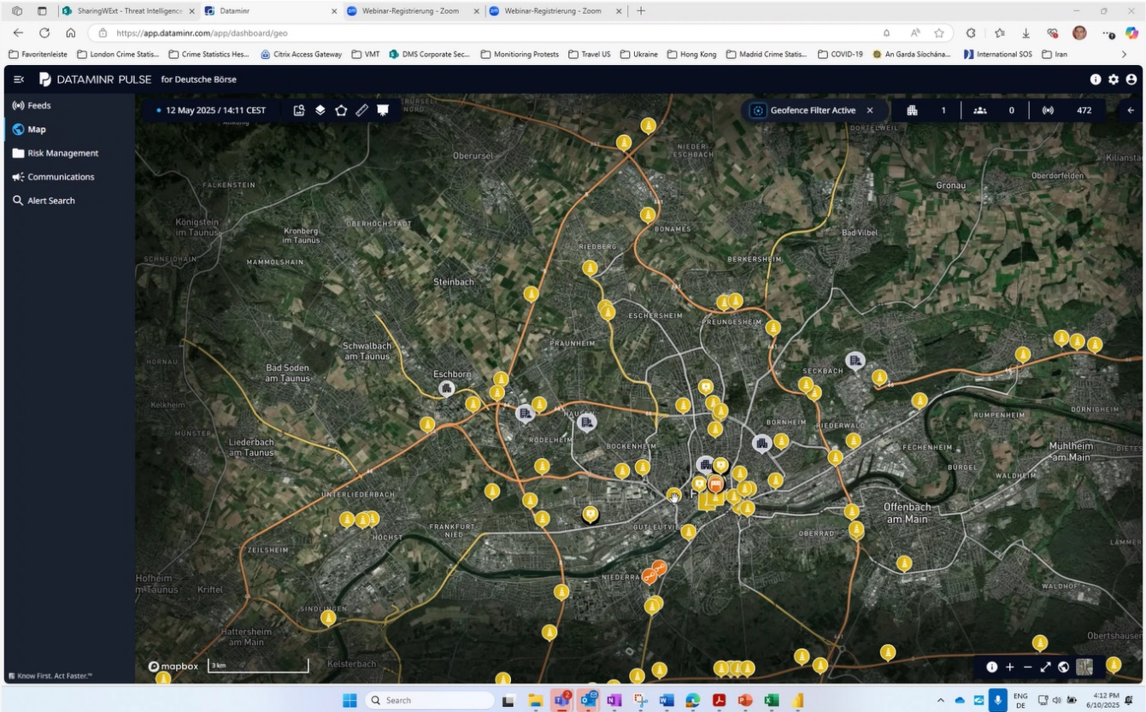  - MISP – MISP is an open-source threat intelligence platform for automated Cyber Threat Intelligence gathering of actionable items. MISP platform is connected with SPLUNK tool via API. SPLUNK gathers Indicators of Compromise (IoC) to detect and respond to security incidents.  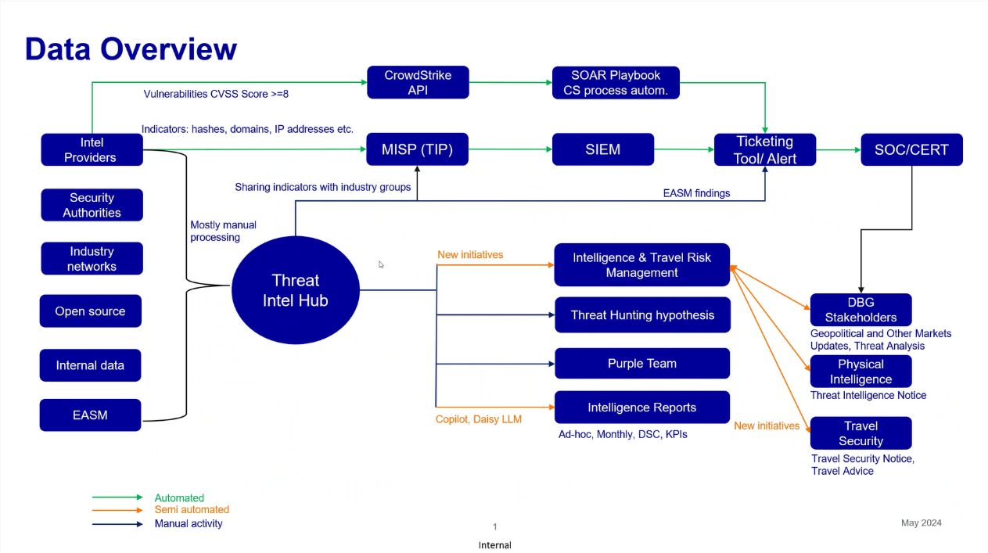  Alert triggered in SIEM:  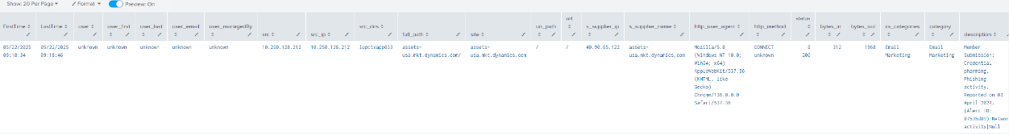  Source Threat Intel feed from MISP:  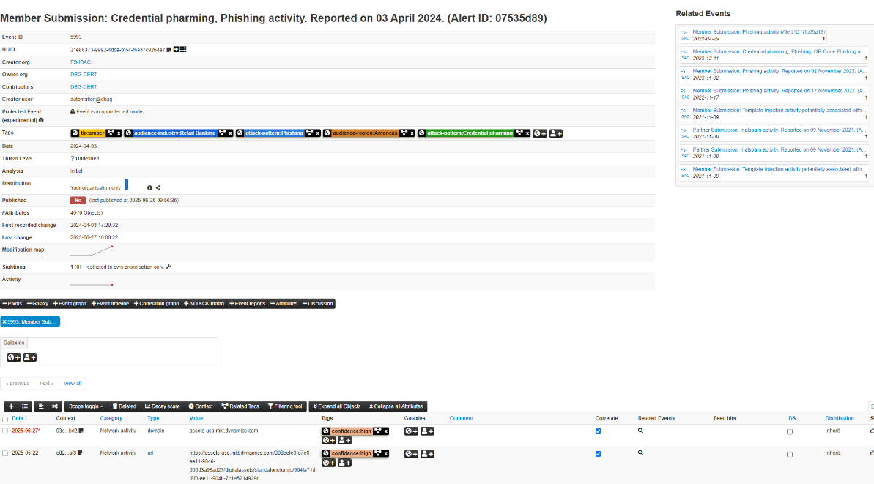  [CUTT-118530] Splunk Alert: Threat - UC2.124_Bad Reputation Domain or URL  Visited – Rule | OK
DORA RTS RMF Article 23 | IA inquired with Olga Wenge (Head of Cyber Defense) to understand if DBG has entered into an information sharing agreement with other financial entities as suggested in DORA RTS on ICT Risk Management Framework Article 23.2.(a).(ii) and understood that DBG has no such arrangements to share cyber threat incidents.

